VEHICLE MANAGEMENT SYSTEM

USING SALESFORCE

INTRODUCTION:

Are you new to Salesforce? Not sure exactly what it is, or how to use it? Don’t know where you should start on your learning journey? If you’ve answered yes to any of these questions, then you’re in the right place. This module is for you.

Welcome to salesforce! Salesforce is game -changing technology, with a host of productivity-boosting features, that will help you sell smarter and faster. As you work toward your badge for the module we’ll take you through these features and answer the question. “ what is salesforce, anyway?”

WHAT IS SALESFORCE?

Salesforce is your customer success platform, designed to help you sell, service, market, analysis, and connect with your customers.

Salesforce has everything you need to run your business from anywhere. Using standard products and features, you can manage relationships with prospects and customers, collaborate and engage with employees and partners, and store your data securely in the cloud.

So what does that really mean? Well, before salesforce, your contacts, emails, follow-up tasks and prospective deals might have been organized something like this[: https://you.be./r9EX3lGde5k](:%20https:/you.be./r9EX3lGde5k%20)

2. PROBLEM DEFINITION & DESIGN THINKING EMPATHY MAP

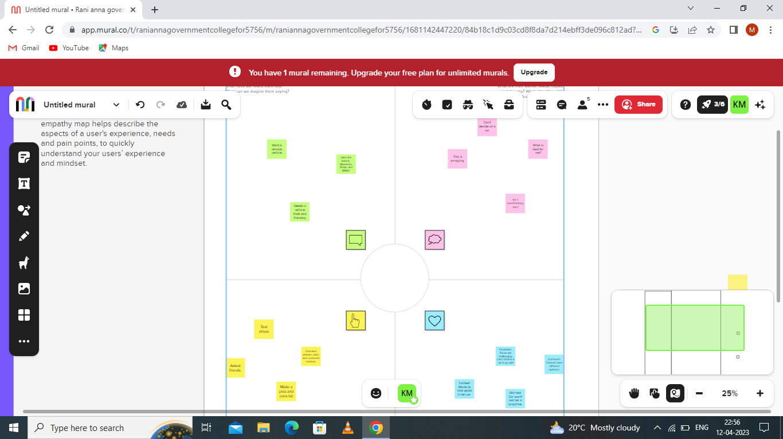

IDEATION & BRAINSTORMING MAP:

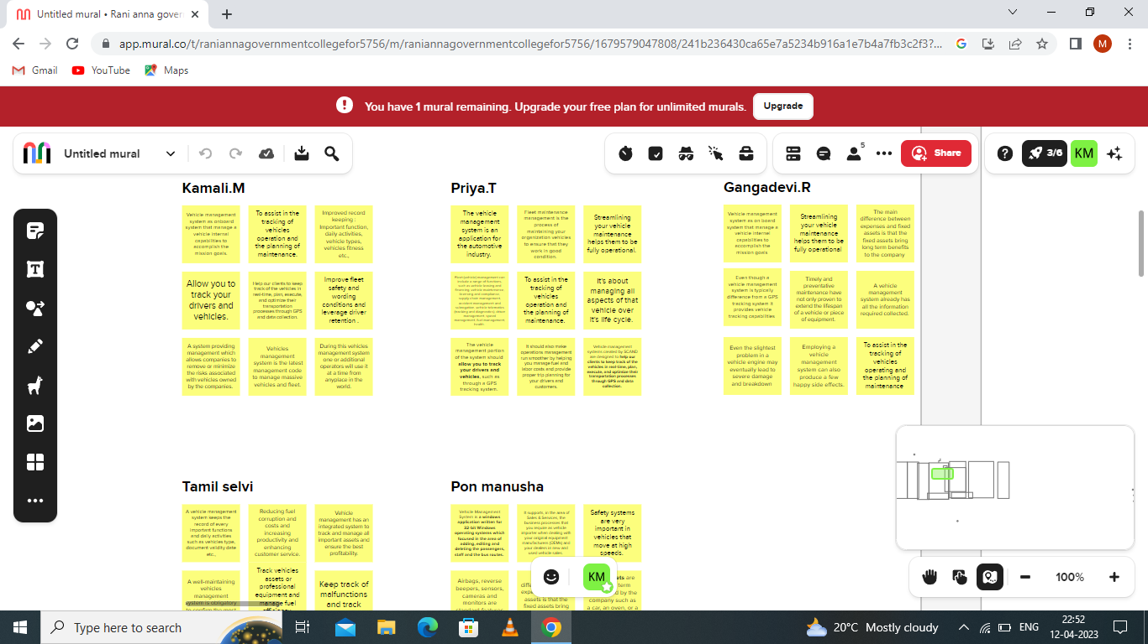

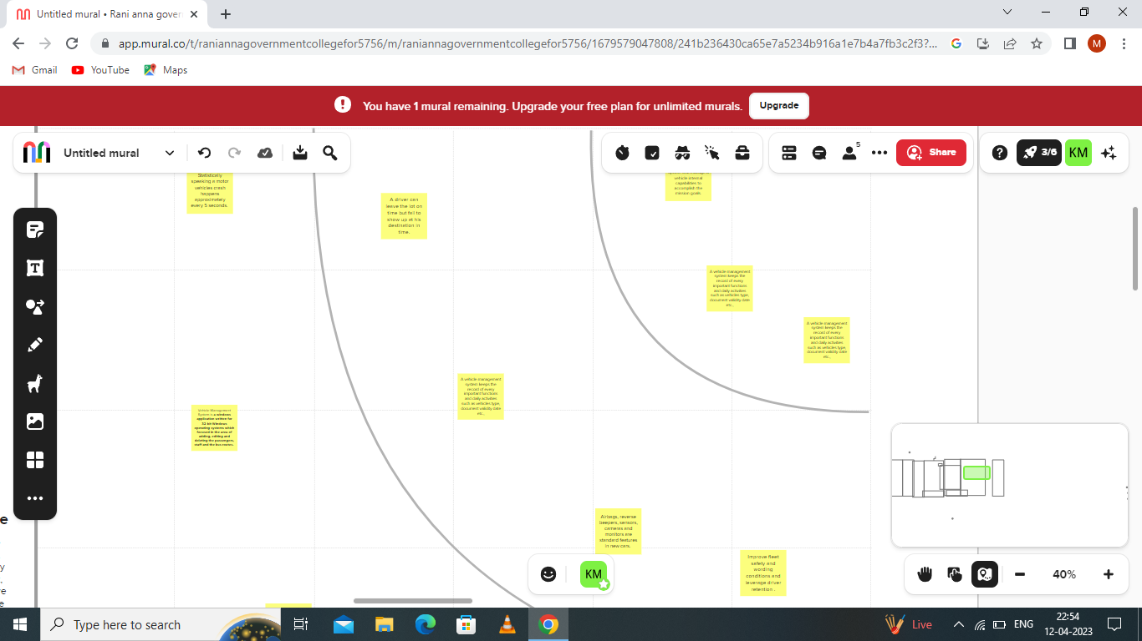

RESULT:

DATA MODEL

|  |  |  |
| --- | --- | --- |
| OBJECT NAME | FIELD IN THE OBJECT | |
| VEHICLE | **Field name** | **Data type** |
| Customer name | Text |
| Customer mobile number | Number |
| DRIVER | **Field name** | **Data type** |
| Driver name | Text |
| Mobile number | Number |

1. Created a salesforce developer org through the website developer.salesforce.com and the setup page appeard.

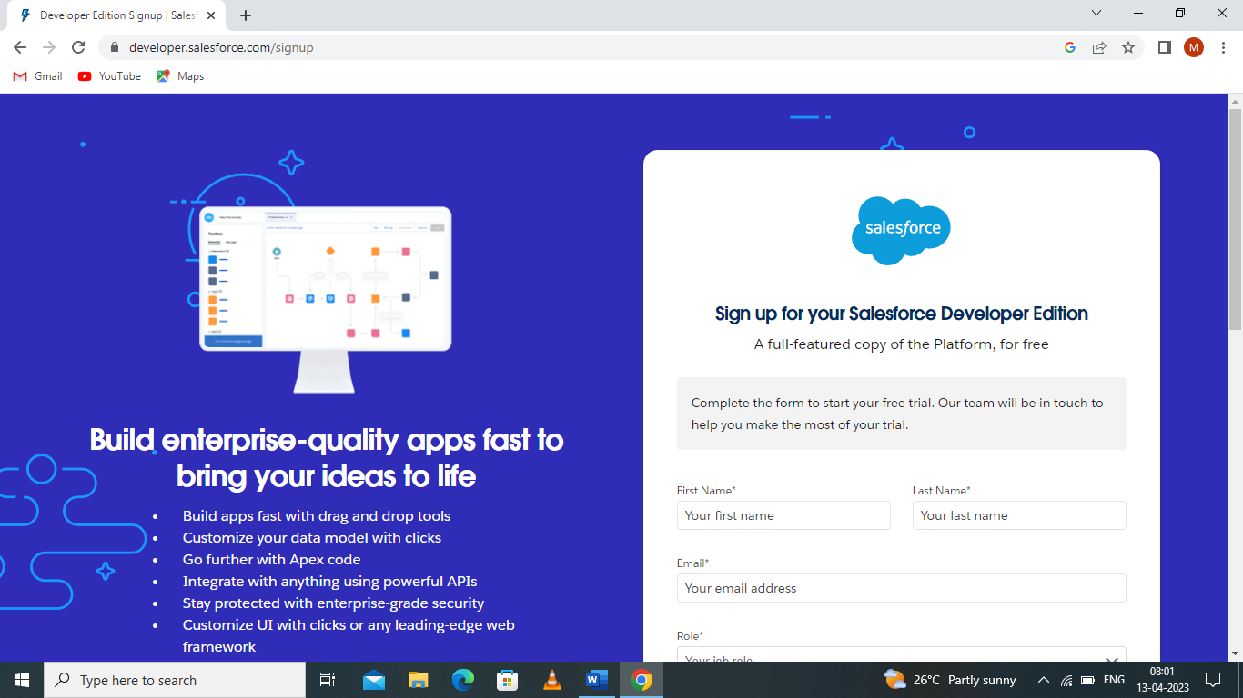

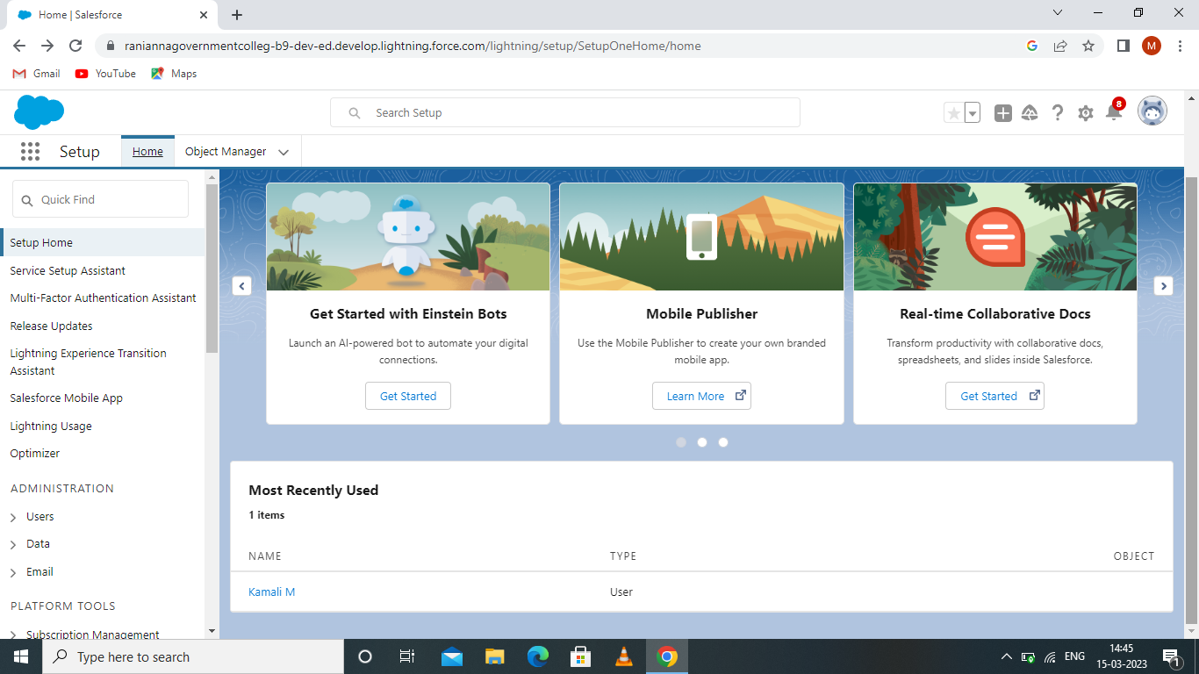

2.Custom object i.e vehicle and driver were created.

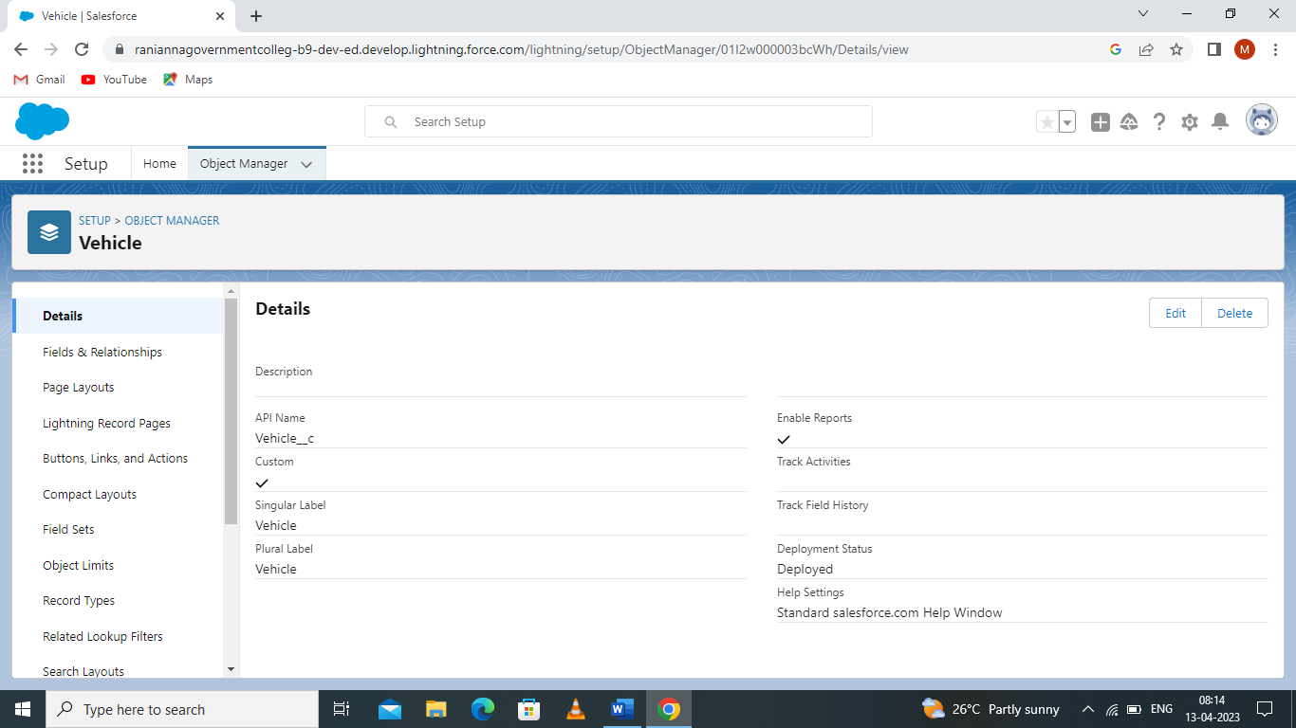

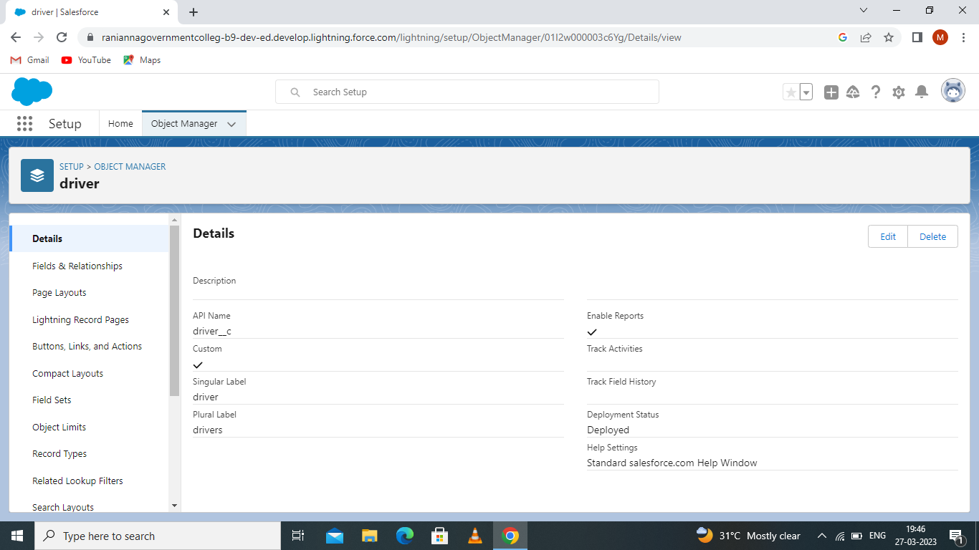

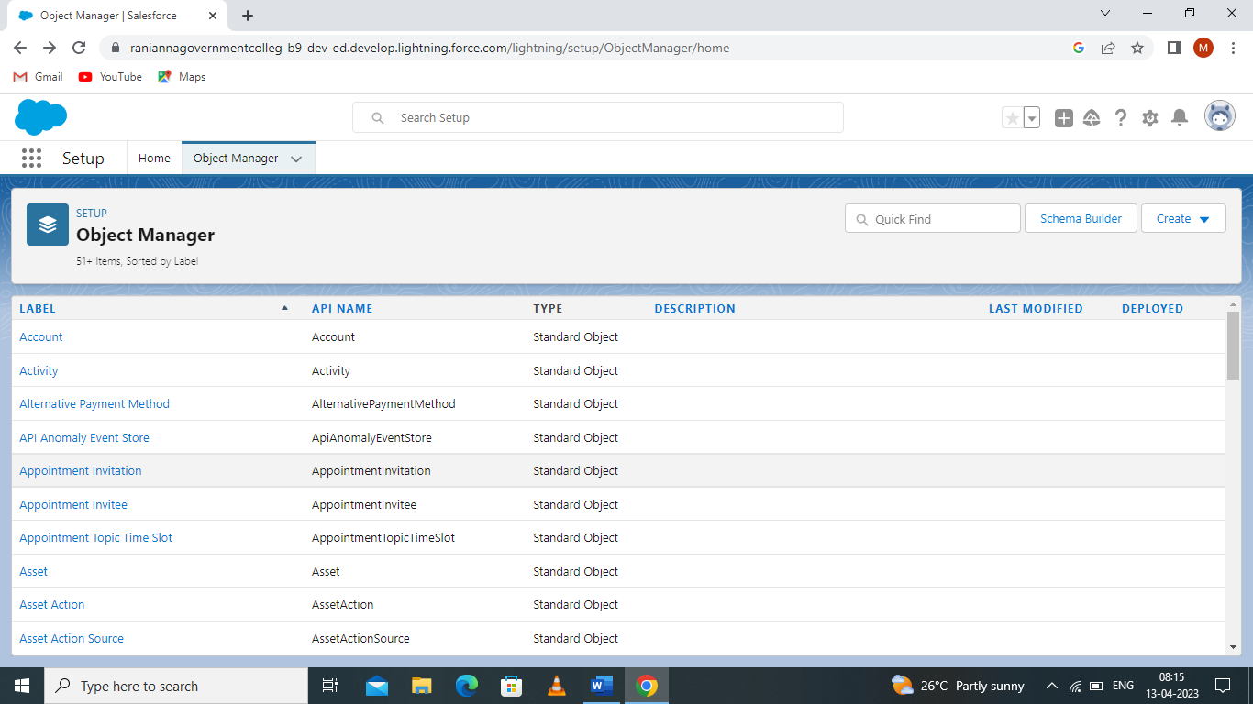

3.Two custom tabs i.e vehicle and driver were created.

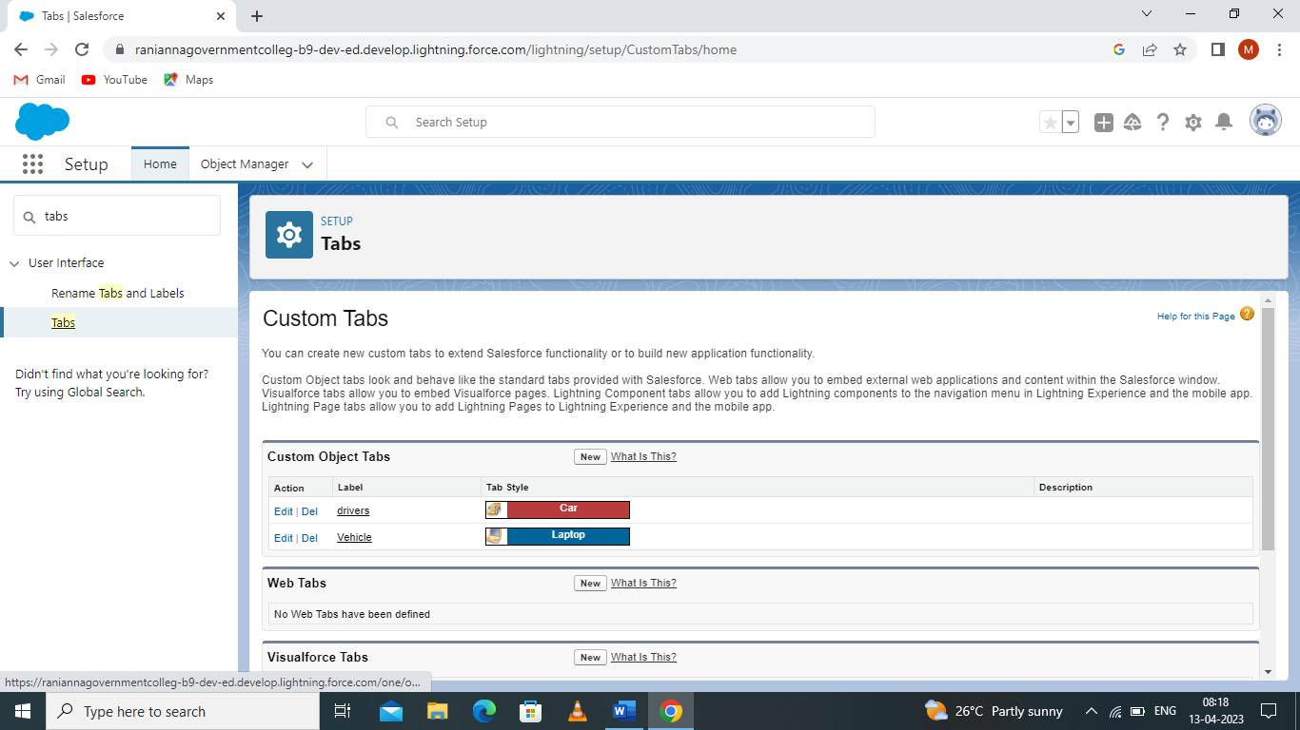

4. Field and Relationship were created.

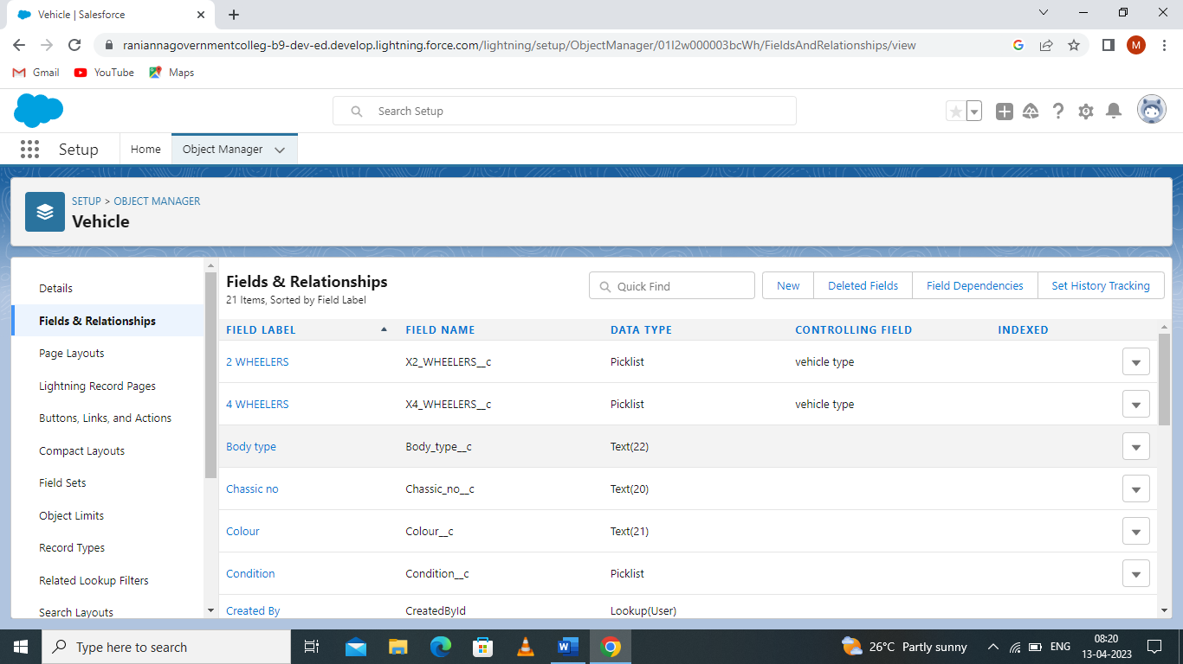

5.VEHICLE MANAGEMENT construction app (lighting app) was created.

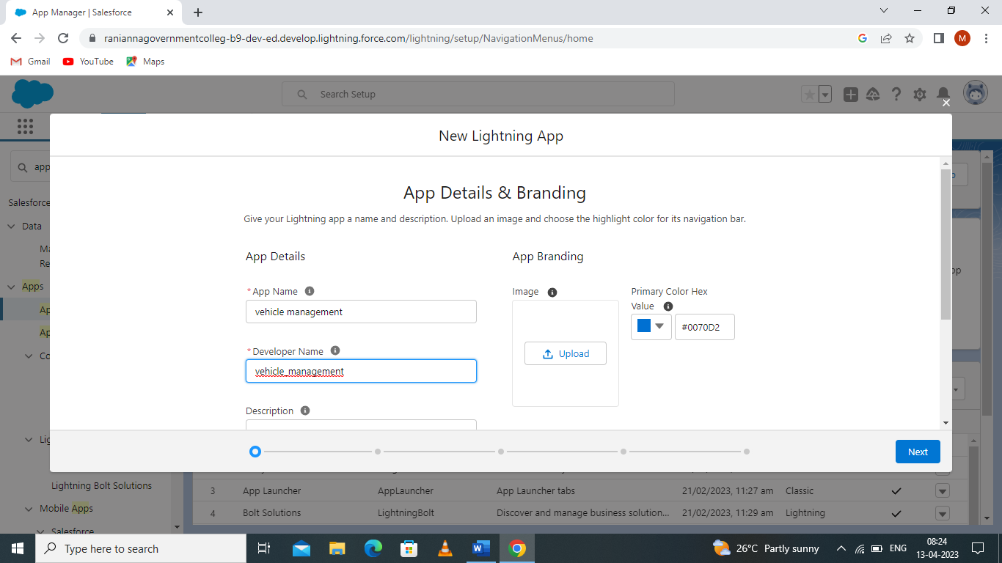

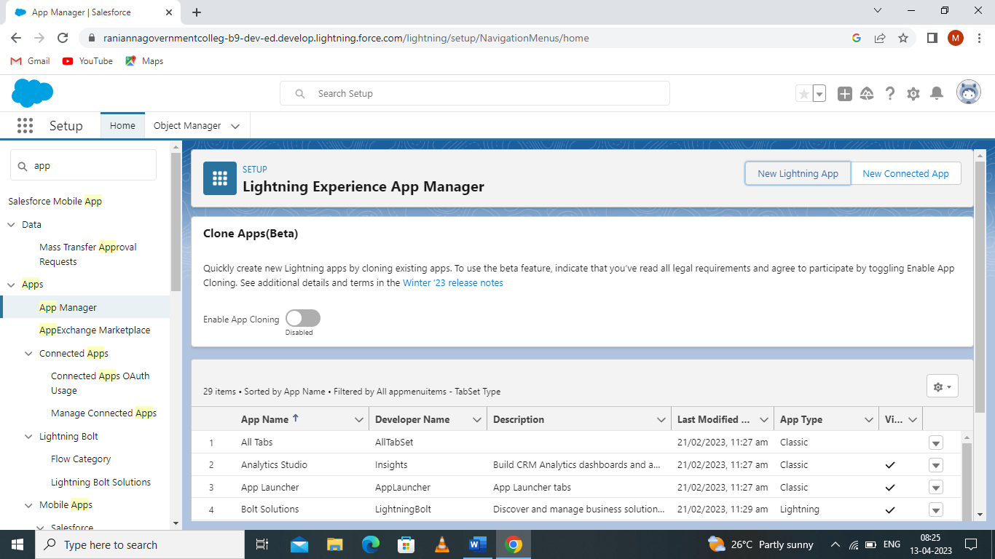

6. Profile was created by assignment object, field and user permissions.

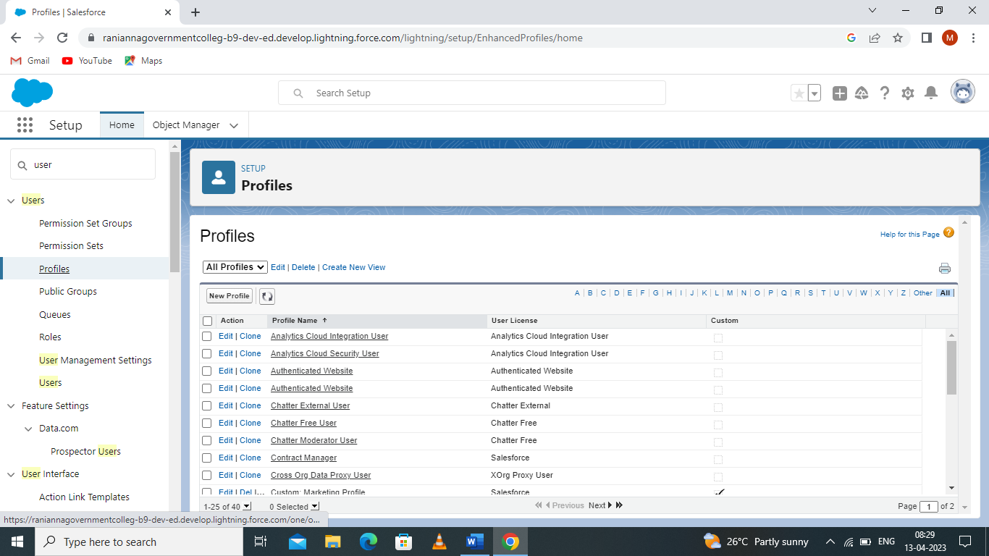

7. Users were created and their roles were assigned to them.

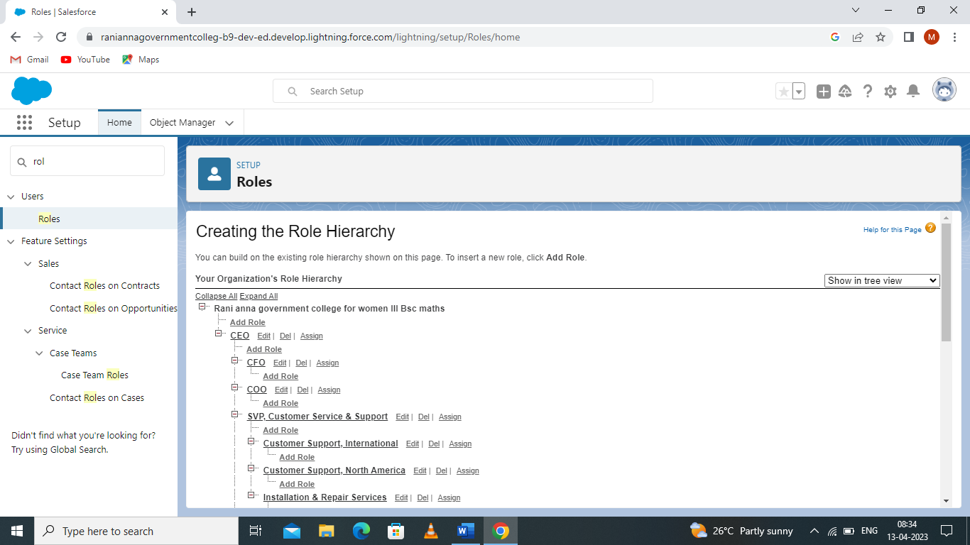

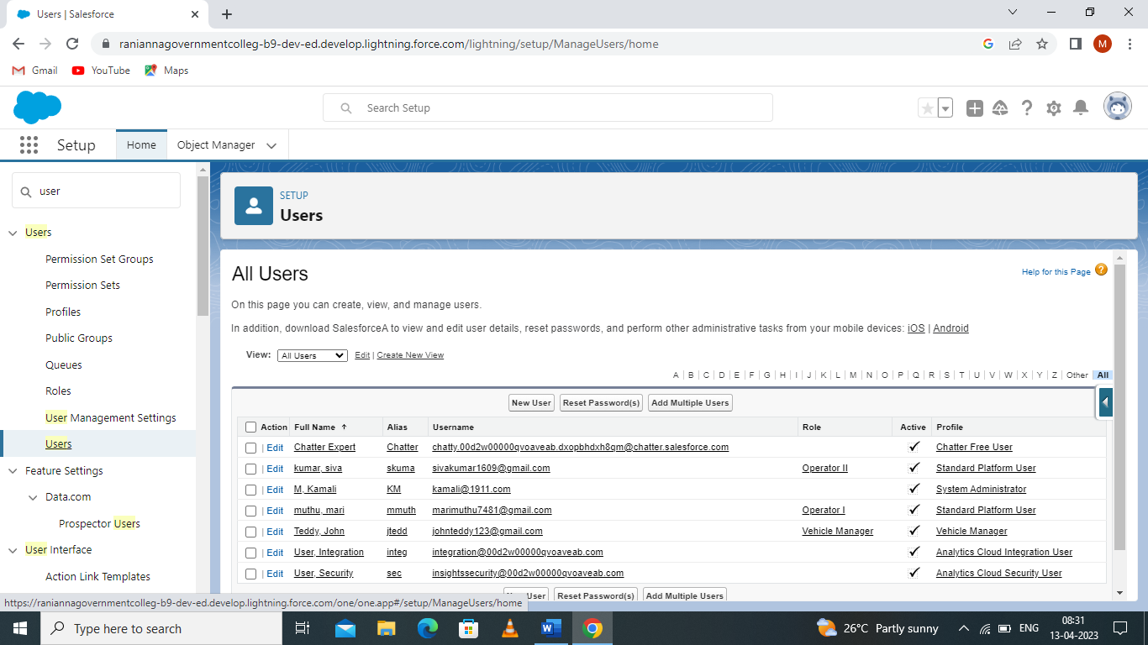

8. A custom report was created.

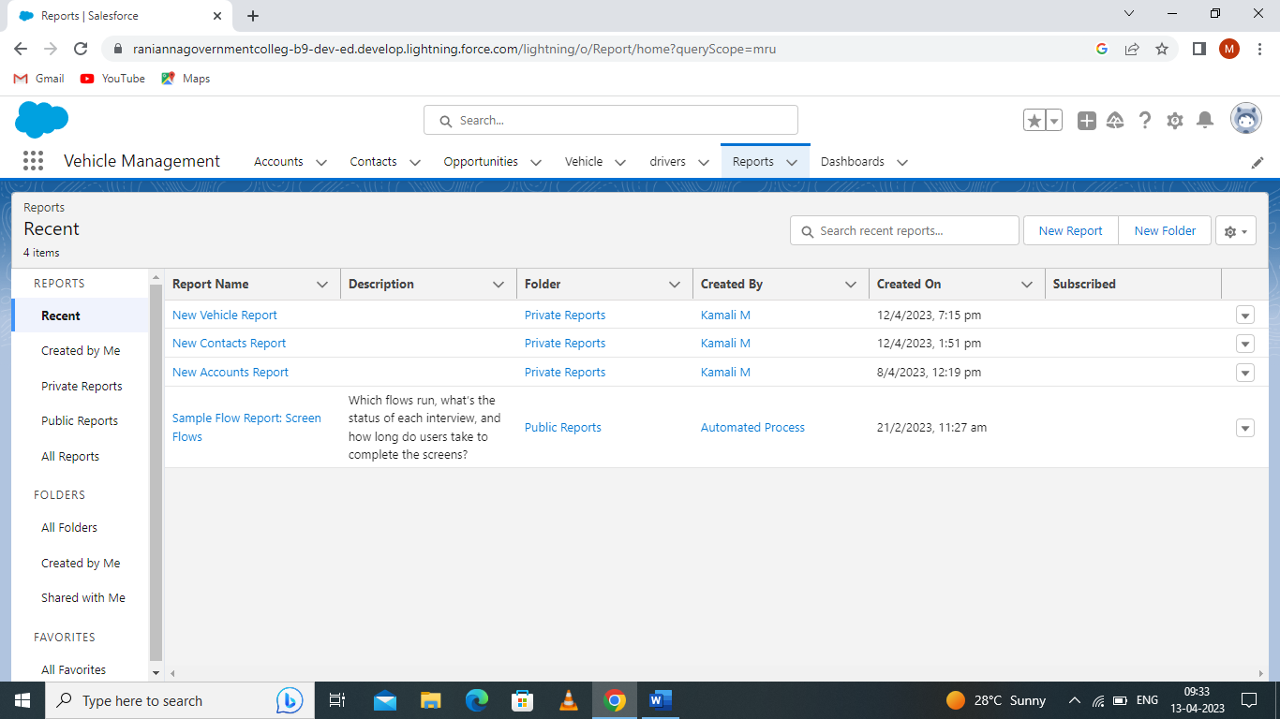

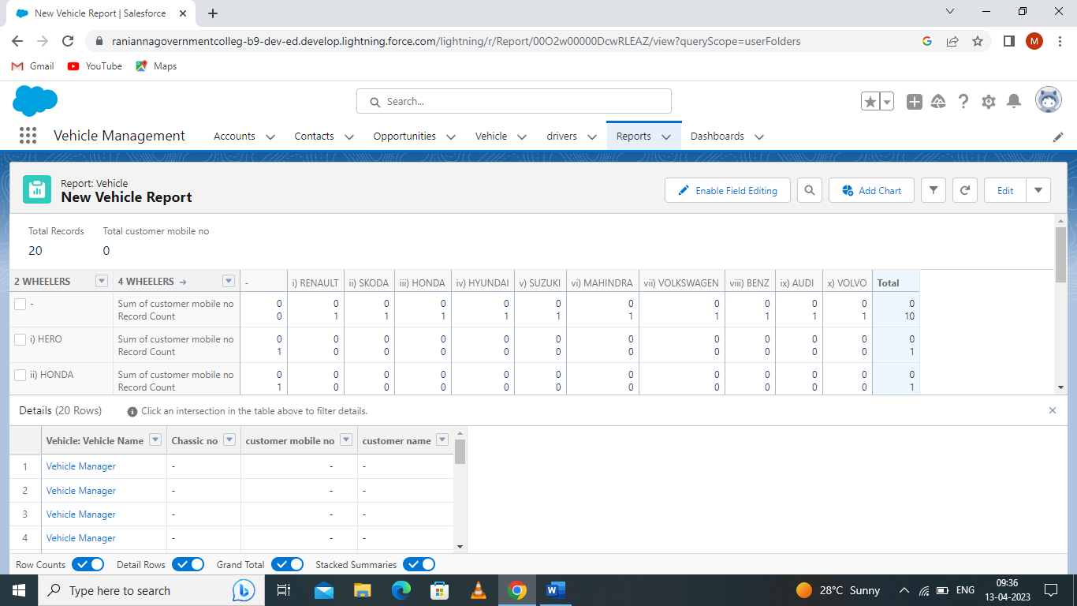

9. A custom dashboard were created.

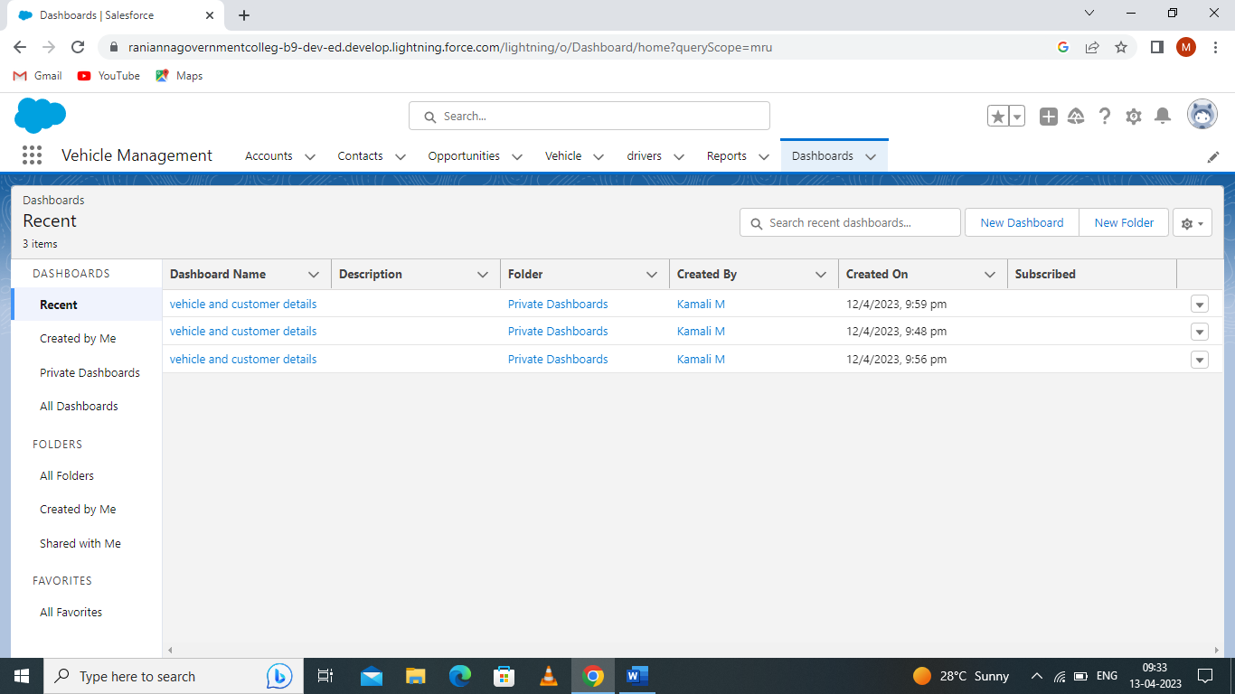

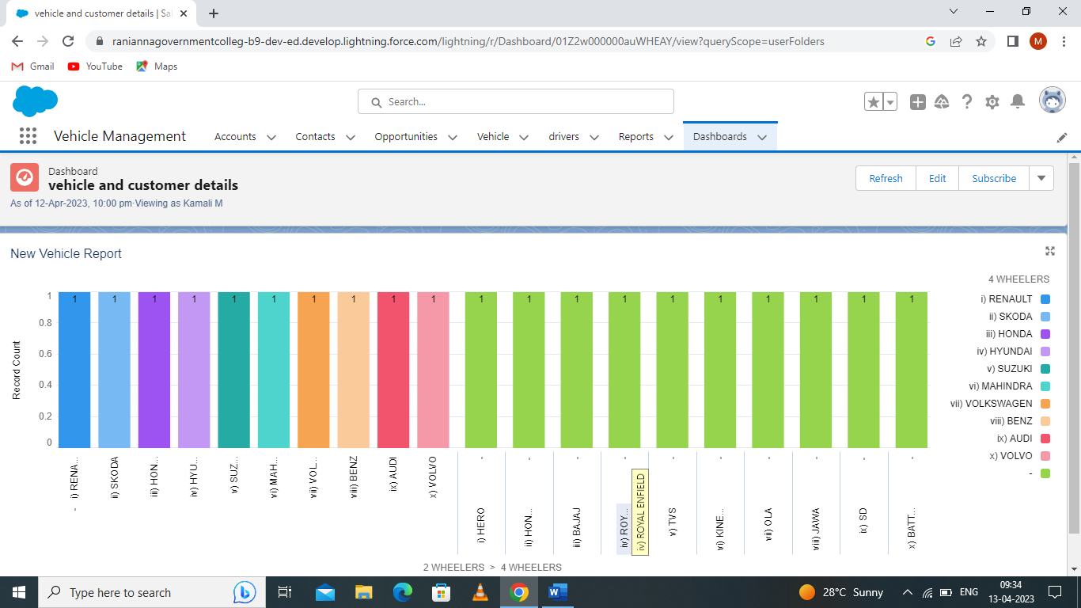

4.Trailhead profile public URL:

Team lead [- https://trailblazer.me/id/malya2](https://trailblazer.me/id/malya2)

Team member 1[- https://trailblazer.me/id/gangr11](-%20https:/trailblazer.me/id/gangr11)

Team member 2 [– https://trailblazer.me/id/ponms4](–%20https:/trailblazer.me/id/ponms4)

Team member 3 [– htttps://trailblazer.me/id/priyt18](http://go.microsoft.com/fwlink/p/?LinkId=255141)

Team member 4 [– https://trailblazer.me/id/tamie13](–%20https:/trailblazer.me/id/tamie13)

5.ADVANTAGES & DISADVANTAGES

Advantages:

1.Good for long drives

2. Personal vehicle meaning it’s upto you where and you want to go.

3.Good for rainy days.

4. Good for daily commutes and for long rides.

5.Maintanence is cheeper when compared to a car.

6.Easier to find parking spot and requires almost no money for parking.

Disadvantage:

1. Takes too much space causing traffic jams.
2. Parking is costly and is quite difficult to find a good spot.
3. Regular Maintenance.
4. Fear of getting your car scratched or dented by another irresponsible person.

6.APPLICATION:

If you are specific about choosing an effective vehicle management application, then here are a few valid reasons why you need to choose our product.

* If focuses to eliminate ground level problems of the business process.
* It gives solutions for every challenges faced by end-user and top-level management.
* It provides comprehensive platform to unlimited vehicle and driver management.
* It delivers instant information on vehicle fitness and fuel tracking.
* Fastest and real-time tracking of Goods movements through web.
* It gives historical data and reports on single click.
* Optimized control on vehicle and driver allocation.
* It enables to get trip wise profitability management.

7.CONCLITION:

Integrating database technologies in vehicle management system is considered controversial by many. The general conception of database systems is that they are highly resource demanding both with respect to memory consumption and computational overhead. Furthermore, database system are considered too non-deterministic to be used in vehicle management systems. However, commercially embedded solutions exist today, with database engines as small as a few kilobytes. Furthermore, many years of research in real- time database management systems shows that these systems can be made deterministic.

8.FUTURE SCOPE:

That’s the prediction of fleet software specialist chevin fleet solutions as more organisations turn to “big data” to meet their transport and asset needs.

As more organisations work to harness so-called ‘big data’ and integrate it meaningfully into their operation, they may be able to pinpoint savings opportunities that extend well beyond a traditional fleet approach.

“For example, we have seen instances where, rather than just being handed the keys to a company car, employees are being offered a range of different travel options or some kind of overall mobility allowance.